

To: Professor Alan Pisano

From: Jessica Cadreau, Jennifer Fong, Cameron Graves, Makenna Hart, Steven Li

Team: Sweet Grid: Team 20

Date: 11/20/16

Subject: The SWEET City First Deliverable Test Report

1. **Project Objective**
   1. The overall objective of the SWEET Grid Solar Module is to give National Grid customers the chance to understand solar power generation in an interactive manner. This allows them to vary power output by simulating different weather patterns.
   2. This module will not only include a visual load that varies with power output, but will also display power output scaled to a realistic value for use in a city.

**2.0 Test Objective and Significance**

2.1 The circuit setup is shown in figure 1. The test procedure will focus on variable power generation as well as data acquisition. Two solar panels will generate DC power and drive a visual load. The circuit is simple overall, but it allows the measurement of voltage and eventually power while also allowing the visual load to actively change with light.

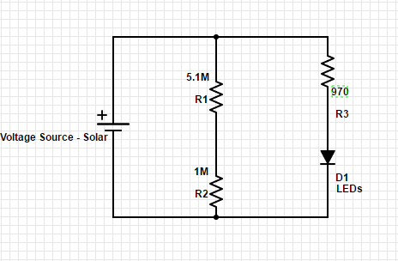

2.2 This deliverable is essential because not only is it one fourth of the project, but the basic circuit and data acquisition of each module is the same. The solar module is the same setup as the wind module and the other two will be a little more complex but are still rooted in the same concepts.

2.3 **Solar Module**

2.3.1 The objective in testing the solar module is to complete one fourth of the project and to understand the basic circuitry needed. Since this is the simplest module, understanding the setup will make the rest of the modules a lot easier. Additionally, ranking the different filters by the amount of voltage outputted when each color is shining on the solar panels will help better understand which colors correspond to different weather patterns (i.e. cloudy, sunny, nighttime).

2.4 **Data Acquisition Software**

2.4.1 The objective of testing the data acquisition software is to understand the basics of what is needed to measure and display data in every module. This is just for measuring the voltage but in the future will measure power consumption.

**3.0 Equipment and Setup**

3.1 **Overall Arrangement - Solar Module**

3.1.1 As shown in figure 2, the solar module includes two solar panels, a 60W light, an MSP430 for data acquisition, and circuit that powers an LED strip while also stepping down voltage. The included 60W light powers two solar panels in series. The solar panels power a voltage divider and an LED circuit. A voltage divider is required to step down solar panel voltage to be read by the MSP430. In parallel with the voltage divider, a 970Ω resistor limits current to a strip of LEDs. The LEDs are attached to a small scale model of the “Rainbow Swash” natural gas storage tower in Dorchester shown in figure 4. 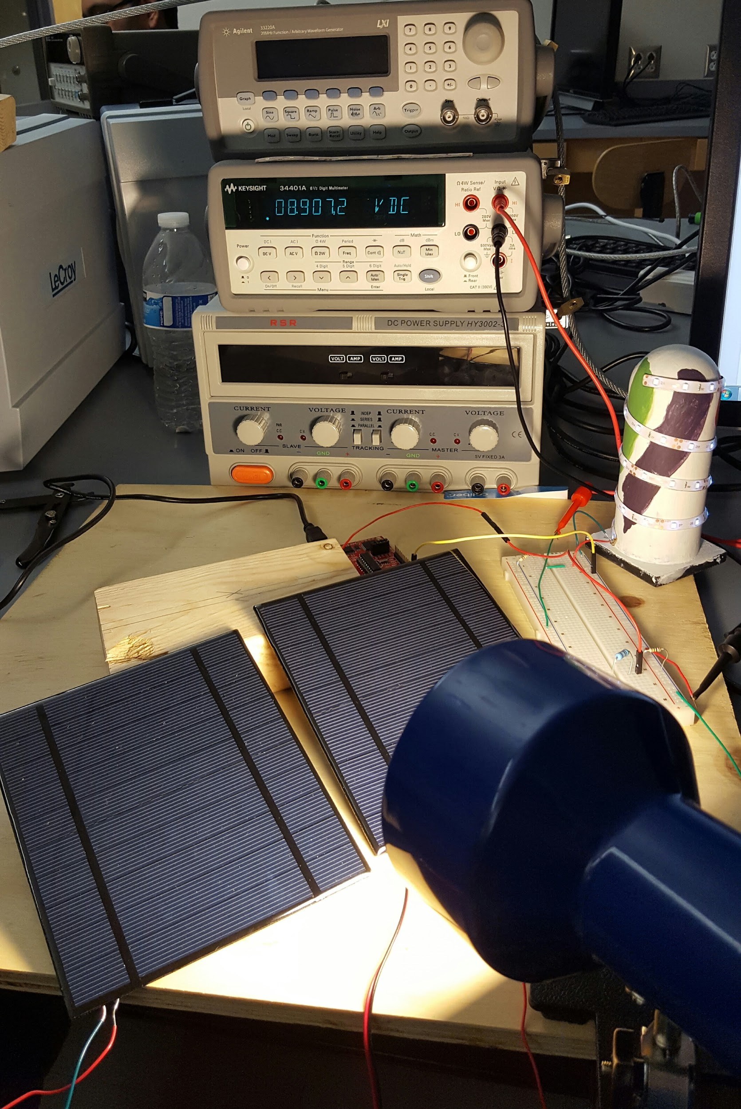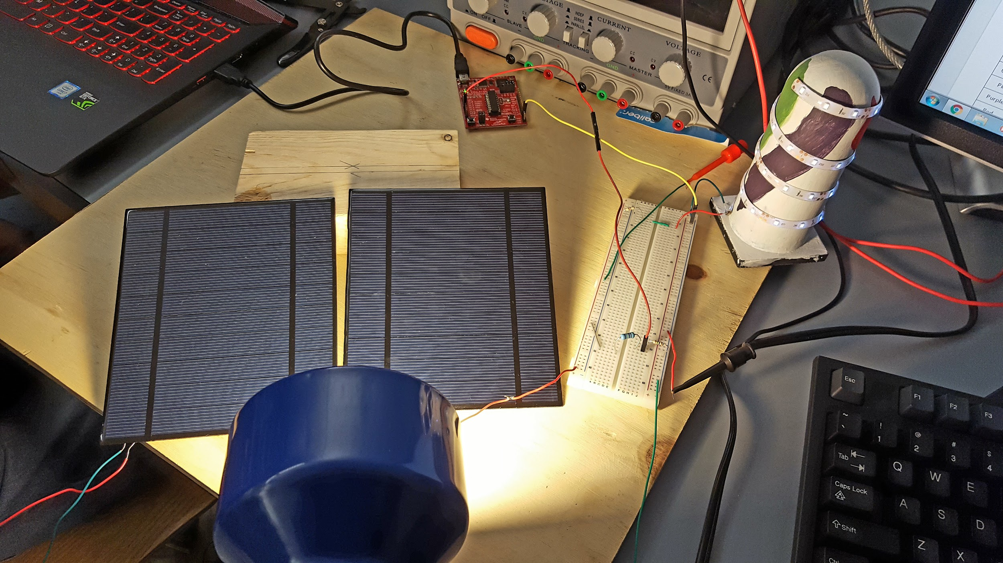

3.2 **Data Acquisition Software**

3.2.1 To acquire data, an MSP430 with ADC built in is connected to the circuit. By using the ADC on the board, values are able to be recorded and shown in Code Composer on a laptop that is connected to the microcontroller. These values are recorded into the expression latest_result which is shown in Figure 5. For the input voltage to the microcontroller, there has to be an upper limit of 3.6V because that is the max VCC value it can have. This is why a voltage divider is required to ensure our values are within this acceptable region. To generate an equation that will convert the ADC values into voltages, tests were run that generated data that would show the relationship between the voltage across the resistor and the value recorded from that resistor. The voltage across the resistor is then stored in the expression called voltage shown in Figure 5. After confirming these values with a multimeter, tests could then begin to generate the equation that would scale up the recorded voltage to what the total input voltage is, which would represent the voltage coming out of our solar panels. With this new equation, we were able to again confirm the voltages with the actual voltage from the power supply. The total input voltage is then stored in the expression input_voltage which is also shown below in Figure 5.

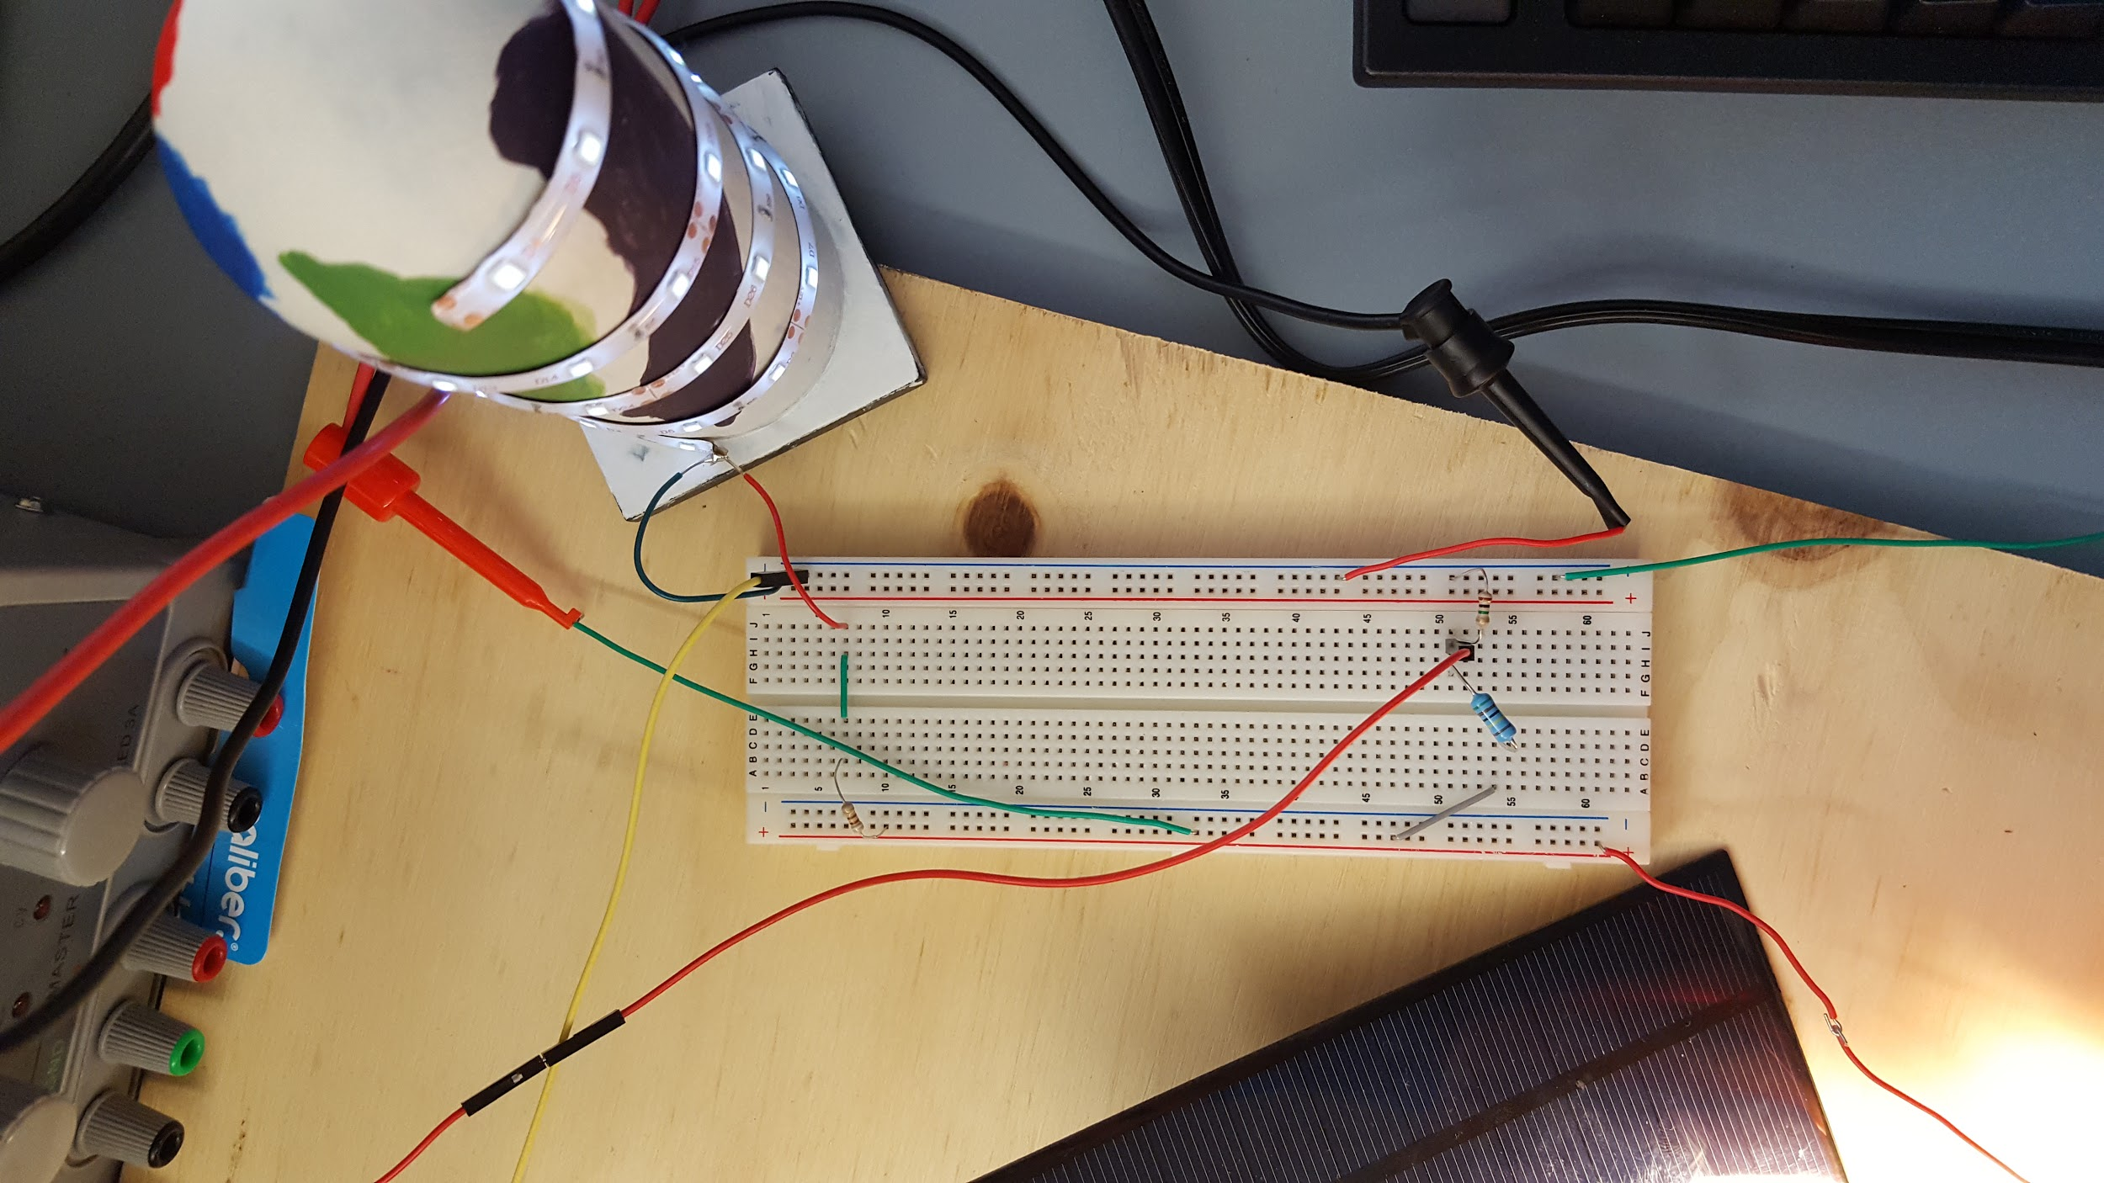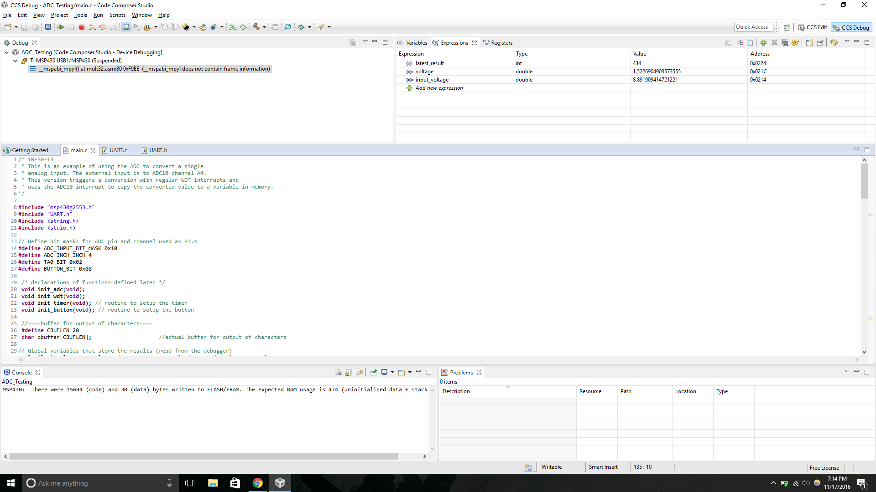

**4.0 Measurements and Data**

4.1 **Solar Module**

4.1.1 For testing the solar module, data was collected using a multimeter to measure the DC voltage being generated by the solar panels when different colored filters were placed in front of the light source. As seen in the table below, it was recorded whether or not the load (LEDs on the LNG Tower) were on or off. From these tests, the different filters were then ranked by how much voltage is generated from the solar panels.

|  |  |  |  |  |  |  |  |
| --- | --- | --- | --- | --- | --- | --- | --- |
| Filter | Trial 1 (V) | Trial 2 (V) | Trial 3 (V) | Trial 4 (V) | Avg Voltage | LED On? | Rank |
| None | 9.03 | 9.00 | 8.99 | 9.00 | 9.005 | Yes | 1 |
| Yellow | 8.85 | 8.80 | 8.83 | 8.88 | 8.84 | Yes | 3 |
| Orange | 8.92 | 8.90 | 8.86 | 8.93 | 8.9025 | Yes | 2 |
| Pink | 8.76 | 8.71 | 8.72 | 8.70 | 8.7225 | Yes | 4 |
| Purple | 8.30 | 8.26 | 8.23 | 8.29 | 8.27 | Yes | 5 |
| Red | 8.28 | 8.23 | 8.23 | 8.29 | 8.2575 | Yes | 6 |
| Green | 8.18 | 8.14 | 8.15 | 8.18 | 8.1625 | Yes | 7 |
| Light Blue | 7.58 | 7.52 | 7.54 | 7.58 | 7.555 | Yes | 8 |
| Dark Blue | 6.70 | 6.45 | 6.61 | 6.70 | 6.615 | No | 9 |

4.2 **Data Acquisition Software**

4.2.1 For testing the data acquisition software, the MSP was connected through a voltage divider to the solar module circuit. The software would take the stepped down input voltage and convert it to the original voltage and display it on the screen. That voltage was then compared to the one read on the multimeter to see how accurate the calculation is.

**5.0 Conclusions**

5.1 **Solar Module**

5.1.1 For the solar module, success is measured in terms of the filters actively changing the LED brightness and voltage outputted by the solar panels.

5.2 **Data Acquisition Software**

5.2.1 For the data acquisition software, the test is successful if the stepped down voltage and the original voltage are shown on the screen and they match the values that are on the multimeter. These values should also change based on what filters are placed in front of the light shining over the solar panels.

5.3 **Summary and Future Plans**

5.3.1 From the measurements taken on the testing day, these tests were successful. One of the next steps for this project is to start building the wind and energy efficiency modules. Additionally the data acquisition software should be updated as to have a more accurate reading and display power generated/consumed on an LCD screen. This can be done by using a raspberry pi or a MyRio. PCBs can also be made once the circuitry is finalized.